**Year 1 Knowledge Organiser: Summer 1**



**Music**

This half term we will continue using charanga, our unit is ‘Reflect, rewind and replay’. This Unit of Work consolidates the learning that has occurred during the year. All the learning is focused around revisiting songs and musical activities.

**DT**

Pupils will interview the key stakeholder (e.g. head teacher) who is redesigning an outdoor space **in the local community** to understand their needs. They will then create a model to communicate their designs. In the focused practical tasks, pupils create structures using card, paper, straws, wood and plasticine/clay.

**Writing**

**Writing to inform** - In this unit, pupils will write their own letters about a topic of their choice. We will be sending them out to an audience we decide as a class.

**Writing to inform** - In this unit, pupils will reflect on their time in Year 1, discussing the advice they would like to pass on to the next Year 1 class. They will create their own memory books and ‘top tips’ (written in the form of instructions) for being a good friend and student in Year 1.

**Reading**

The class author focus for Year 1, is Jill Thomson. We are currently reading several of his texts in our class read aloud, such as the owl who was afraid of the dark and the hen who wouldn’t give up. Our daily Phonics reading sessions focus on reading the sounds we already know, reading fluently and developing our comprehension. At the end of the day during our class read alouds this is where we focus on voice choice.

**Religion and World Views**

This unit introduces pupils to the key religious vocabulary of prayer, praise and worship. A clear conceptual understanding of the meaning of these words is important as pupils will revisit them many times throughout their learning in Religion & Worldviews, building a more nuanced understanding of their importance from multiple perspectives.

**History**

Our history topic this half term is homes through time. This topic looks at how homes looked different in the past, using pictures and videos. We have chosen to focus on homes because it is a very tangible area that pupils can relate to in their own lives.

**Science**

In this unit our topic for the term is ‘humans’. We will looking at human body parts and senses. When discussing each sense, pupils also have the opportunity to see how these senses differ in other animals, and so have the opportunity to review – and therefore further embed – learning about mammals, birds, fish, amphibians and reptiles.

**PHSE**

The children will be looking how we can look after eachother and the world?

**PE**

PE will be every Tuesday with Mr Wood, please ensure your child is bringing in the correct PE kit. They will be focusing target games – athletics.

**Maths**

This half term we will be consolidating our knowledge of our number bonds to 8. We will look at place value within 100, this expands our previous knowledge on place value with even bigger numbers. Finally we will look at money and time.

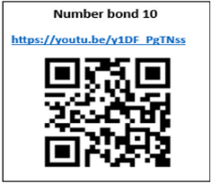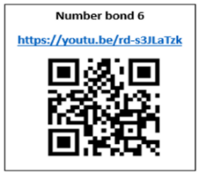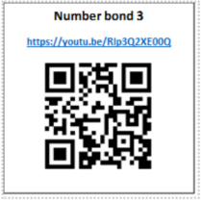**

**History**

In order to support your child in history this half term, these videos are really helpful:

5-minute [**video**](https://www.youtube.com/watch?v=23JzUoU4vBM) by Lucy Worsley on the history of toilets

5-minute [**video**](https://www.youtube.com/watch?v=ey7vvsxmkhk) about gong farmers, who had the role of cleaning communal toilets

1:20 [**video**](https://www.youtube.com/watch?v=mE44GsGKxVc) of a tour of a Tudor house, narrated by a child

**Maths**

Please ensure that your child is practicing their number bonds at home, we practice these in class everyday, your extra support at home will secure this knowledge further. You can also watch the videos below by using the QR codes, which will help you to understand how we teach number bonds at school.

**Writing**

A family scrapbook is a great way to save memories and jump-start your child’s writing. Use an inexpensive photo album to keep souvenirs of things you do together. This can include photos, ticket stubs, and found objects, like pretty leaves.

Your child can begin by writing the date and a line about where you were and what you did. Then, you can work together to write a more detailed summary.

**Reading**

You can support your child at home by ensuring that you are reading with them daily and logging their reading on learningwithparents.com through either a comment, picture, or voice recording! At school we have lots of books that your child can borrow and take home, these can be exchanged as many times as you would like!

**Science**

In order to support your child in science this half term, you can visit this website

<https://www.stem.org.uk/resources/community/collection/12726/year-1-animals-including-humans>

<https://www.bbc.co.uk/teach/class-clips-video/science-ks1-the-human-body/zf8jqp3>

There are quizzes and different activities to work through.

**How to help at home…**